By: Charlen Baloukjy
03/19/2026
- Purpose:
The purpose of this CTF is to retrieve 2 flags via Server-Side attacks.
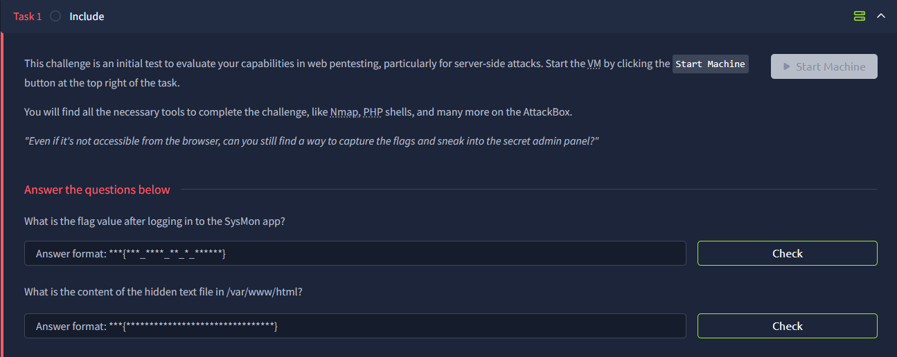
- Methodology:
To start, I used nmap to scan available open ports. These are the results:
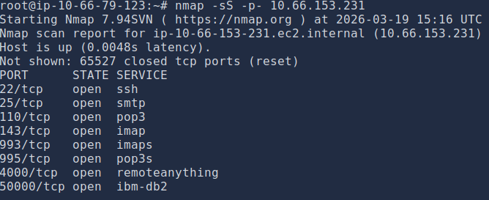
There are quite a few open ports. However, we can exclude Ports 22, 993, and 995 as we won’t be using ssh and the TLS versions of IMAP & POP3.
Next thing I did was go deeper into each of the relevant ports by using nmap again on the specific ports.
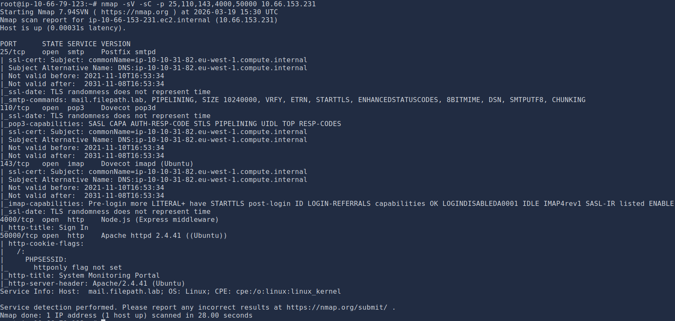
From these results, we can see that the host for these ports is mail.filepath.lab, as well as the commands that are accessible with each service. Moreover, we can see that port 4000 is HTTP with a title of “Sign In” as well as port 50000 with a title of “System Monitoring Portal”. It can be inferred that Port 50000 will have the first flag, based on the first challenge question.
To start, I tried accessing port 4000 on FireFox, which successfully displayed a login page providing default credentials “guest/guest”.
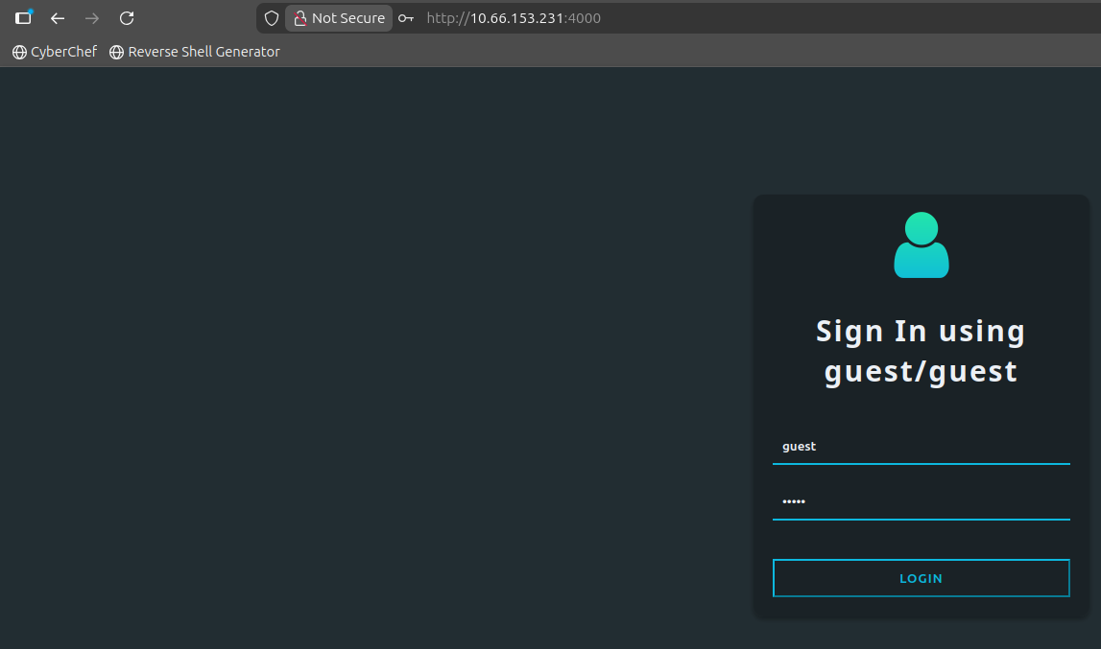
After logging in, I am shown a “Review App” page that displays “my” profile as well as friends that I can add.

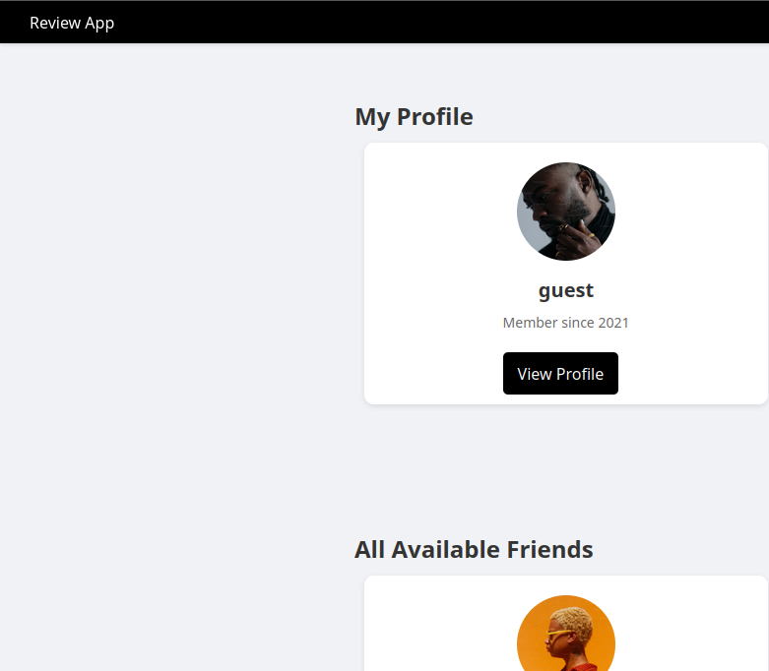
I clicked on View Profile, where I was able to see some details. One interesting detail was “isAdmin: false”. If there is a way to set this to true, then we will be able to leverage our privileges and perhaps retrieve a flag.
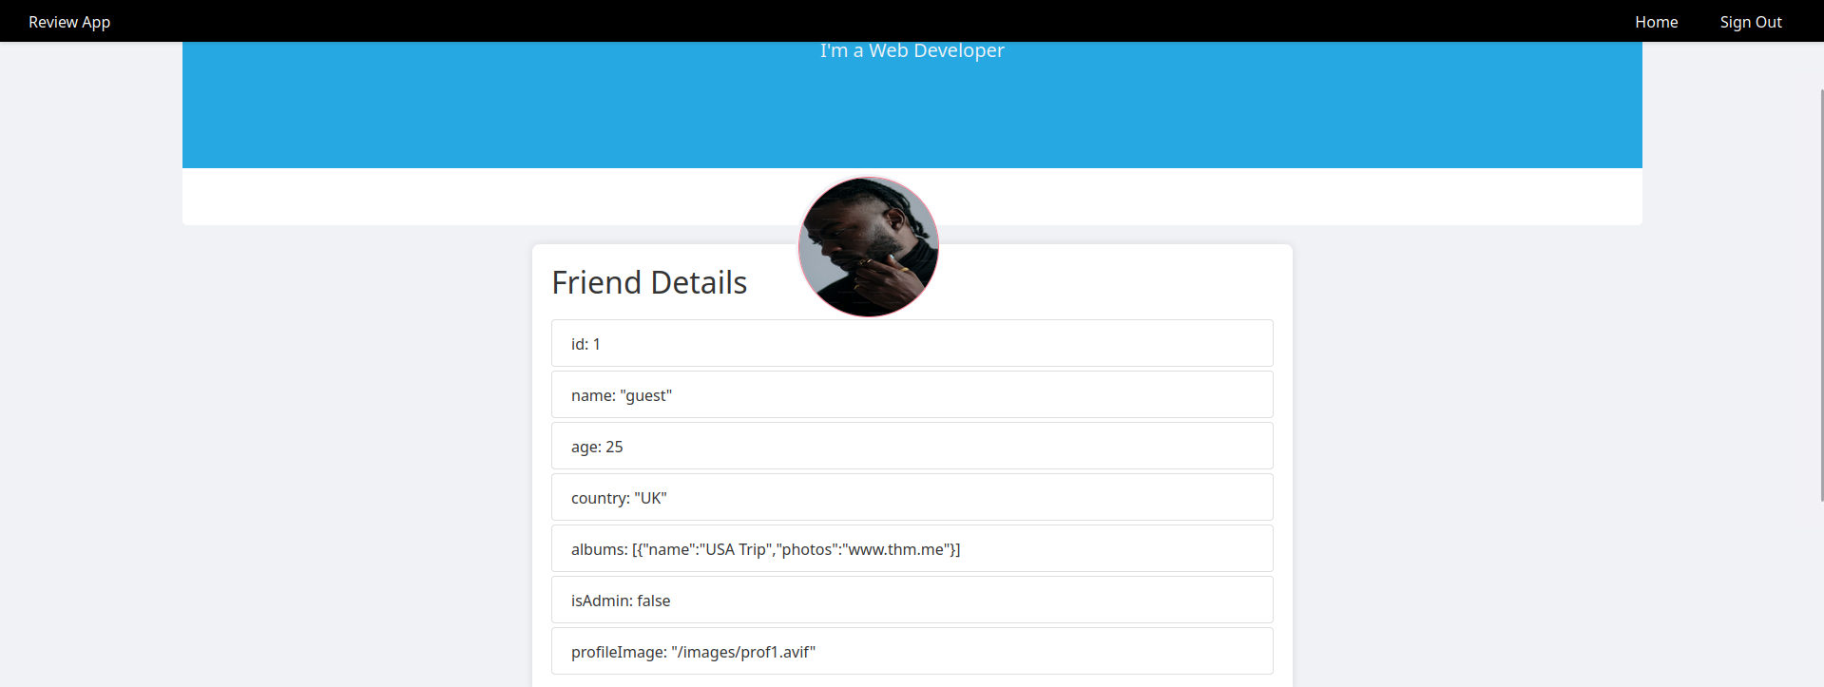
After playing around for a bit, I realized that I could edit the details using the “Recommend an Activity to guest” form that is under “Friend Details” by being able to change the country from UK to US.
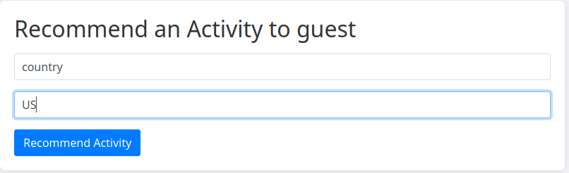
The changed country can be observed in the image below:
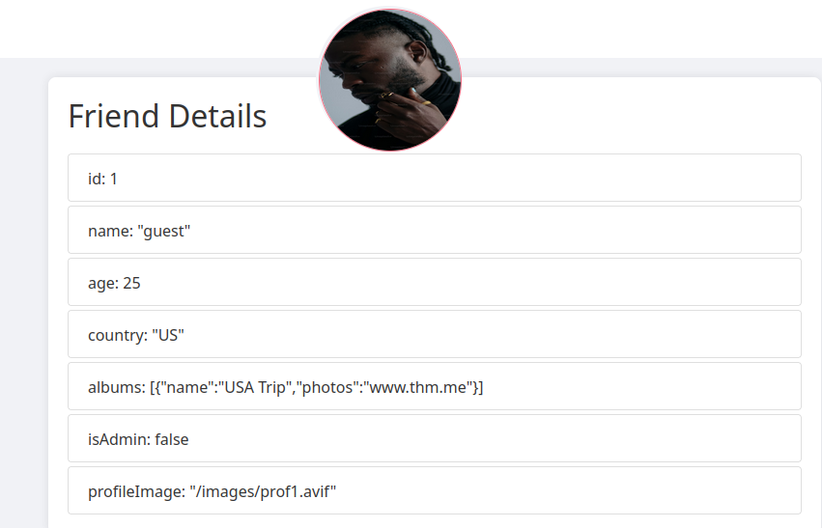
So, next thing I did was set the isAdmin flag to true, and by doing that I was able to unlock 2 new endpoints (API & Settings) as can be seen in the top right of the image below.
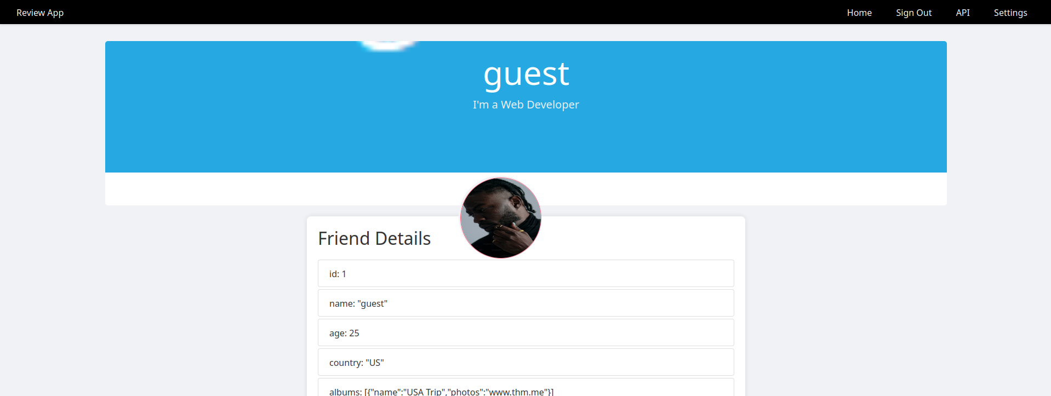
In the API endpoint, there are 2 APIs that are only accessible to admins; Internal API & Get Admins API.
We can see from “Get Admins API” that there are credentials which can be useful to us to obtain access to SysMon, but the passwords are unknown. If we can somehow have a connection to the API, maybe then the credentials will be sent over in plaintext.
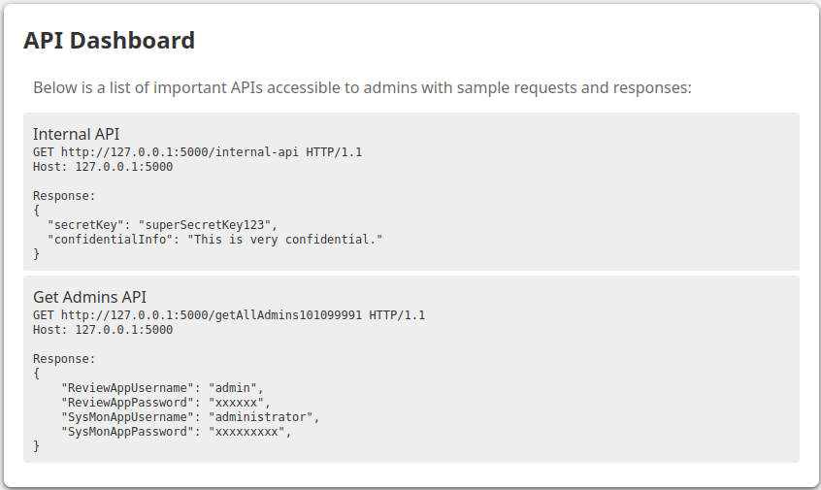
Next thing I did was look over the Settings. In the settings, it is possible to upload a URL that the webpage interacts with to upload the banner image. This might be a possible SSRF (Server-Side Request Forgery) vulnerability. Since the URL in the picture below is linked to an external site, it is possible for an attacker to craft their own malicious URL where they can steal information and more, possibly connecting to the APIs that were talked about earlier, in our case.
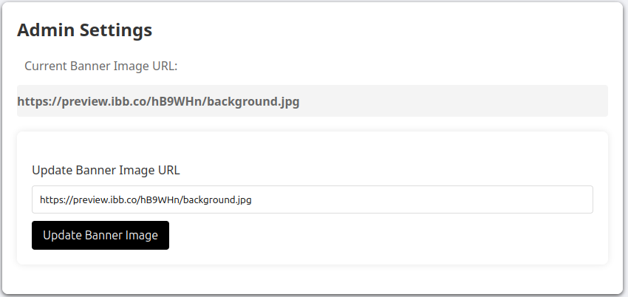
To make sure that the server doesn’t validate the provided URL, I configured a python HTTP server to see if I’ll be able to establish a connection with the webpage.
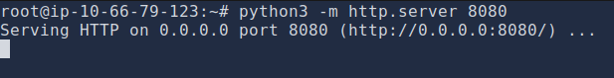
Then, I replaced the Banner Image URL with my machine’s IP and updated the banner image.
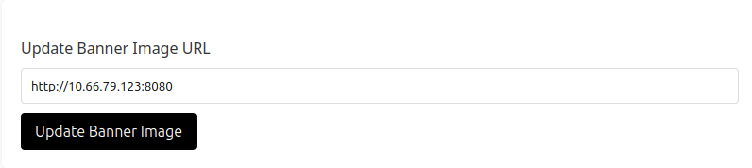
On the left side, we can see that we got a “GET” response after updating the banner image, successfully validating the SSRF vulnerability.
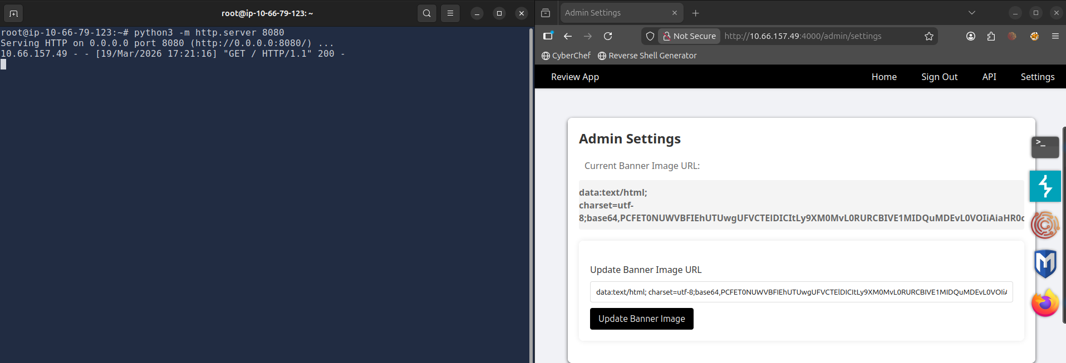
Now, it is time to establish a connection with the “Get Admins API” to retrieve the hidden credentials.
So, I replaced the Banner Image URL with the API’s GET address.
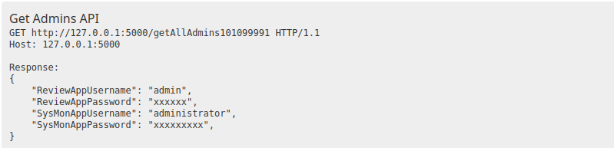
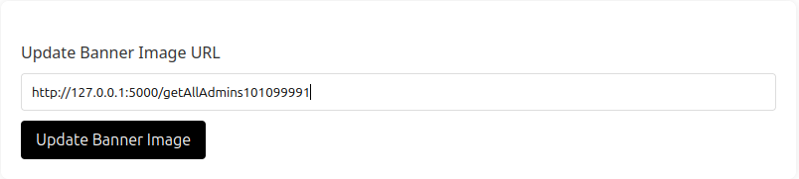
I then took the base64 encoded response and decoded it using cyberchef.io.
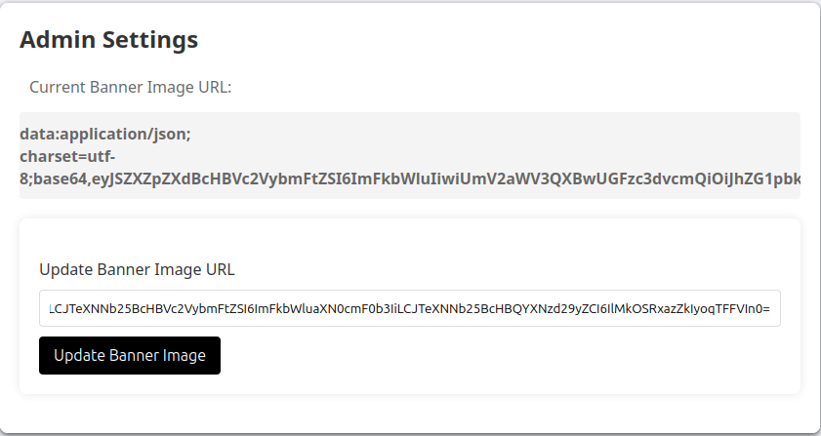
*Note that the entire response of the picture above is not shown*
The result of cyberchef showed the credentials needed to login to SysMon.
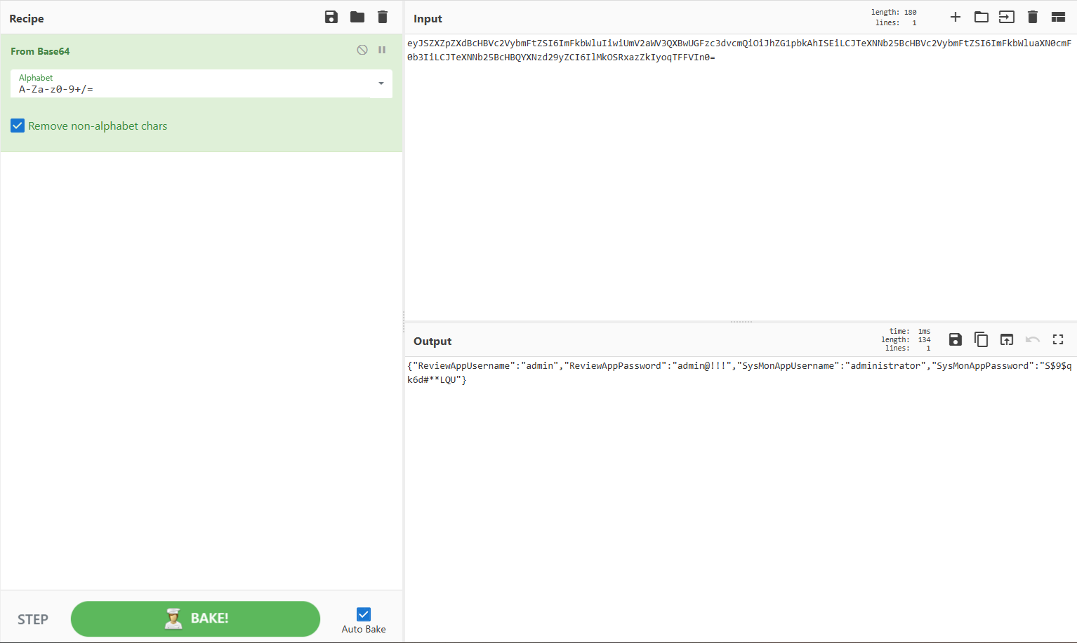
Recalling the SysMon app being hosted on Port 50000, I then navigated to that port on FireFox. Over there is a login endpoint that requires the credentials we obtained.
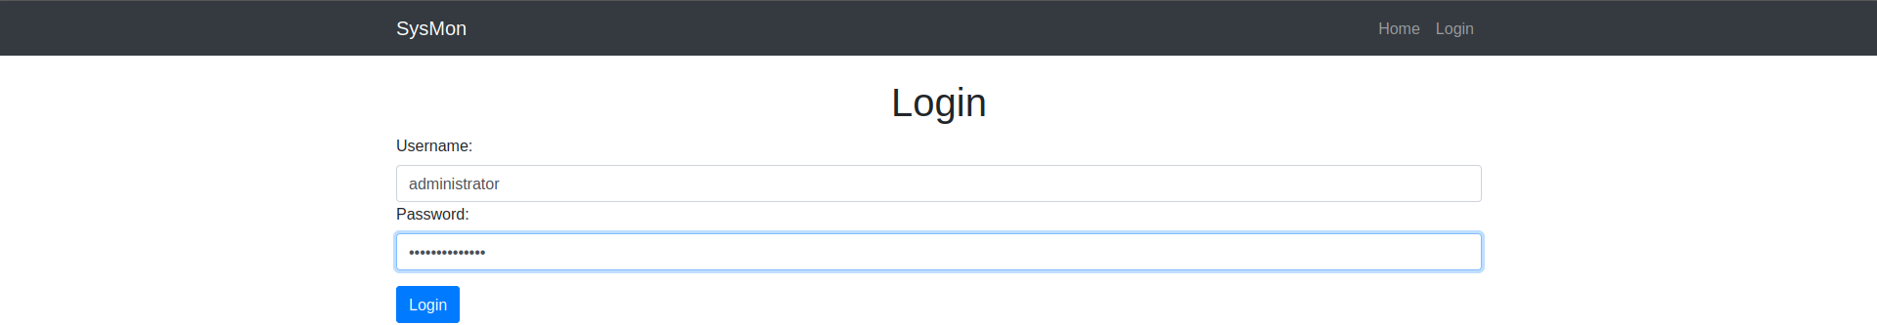After inserting the credentials, we successfully logged in to the system, where the first flag was up for grabs.
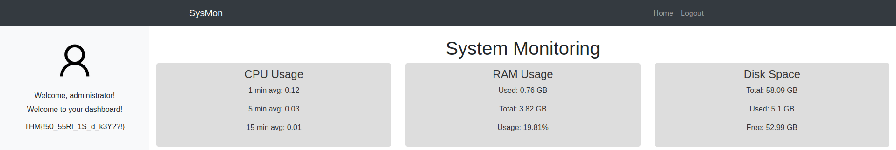
Flag 1 is now captured.
Flag 2 requires us to retrieve it from /var/www/html.
Since there was nothing else to explore in the SysMon webpage, I decided to look at the source code. Luckily, I was able to find a query parameter that could possibly be a vector for Local File Inclusion (LFI).
profile.php?img=profile.png
To make things clear, an attacker can replace profile.png with something like ../../../../etc/passwd, possibly traversing directories and eventually accessing /etc/passwd, where user information can be captured.
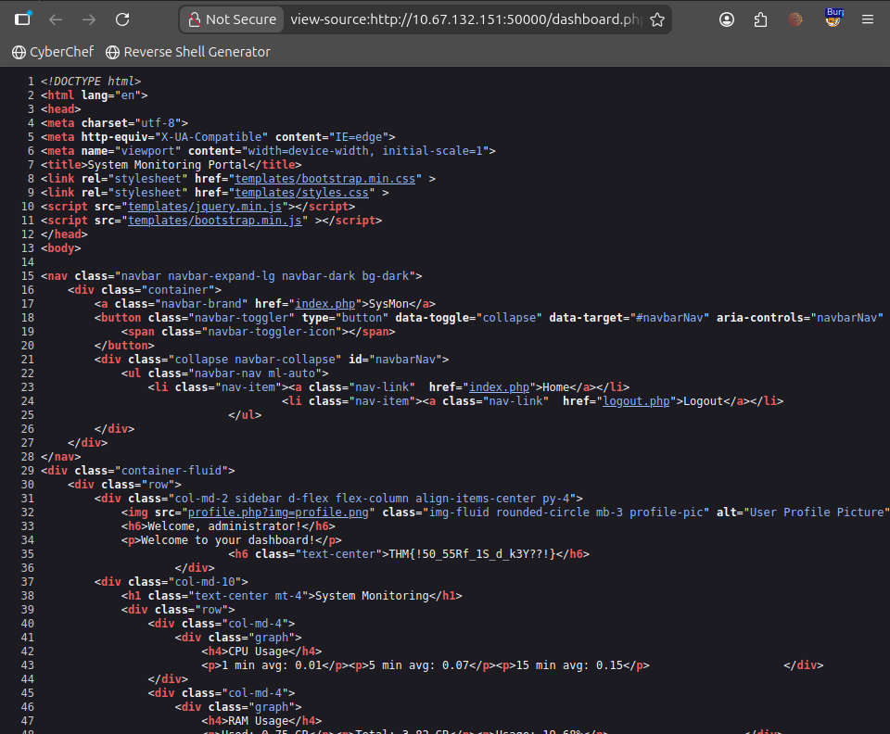
To test it out, I opened up BurpSuite, captured a connection to the above endpoint parameter, and then sent it to Intruder to fuzz ?img= with LFI payloads.
The payload I used was LFI-Jhaddix.txt from SecLists, which can be found on TryHackMe’s Attackbox using the following path: /usr/share/wordlists/SecLists/Fuzzing/LFI/LFI-Jhaddix.txt or online.
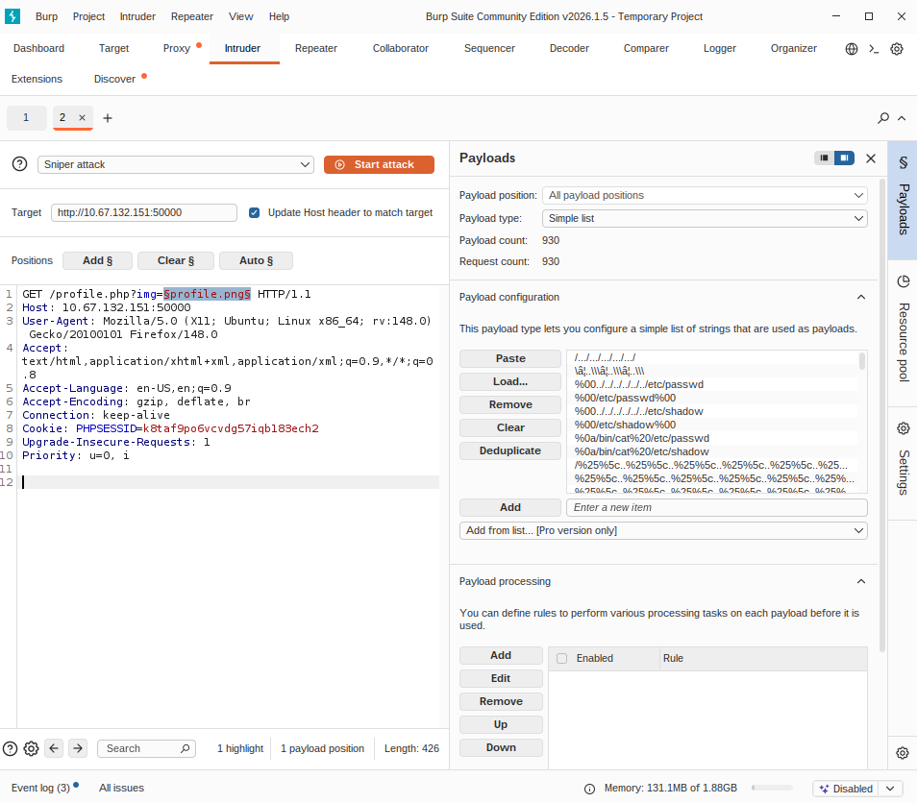
*Note that fuzzing will take some patience and time*
After a while, I was able to obtain a successful payload: ....//....//....//....//....//....//....//....//....//....//....//....//....//....//....//....//....//....//....//....//....//....//etc/passwd
From the response, we can see 2 users (joshua & charles) that could be of interest to us:
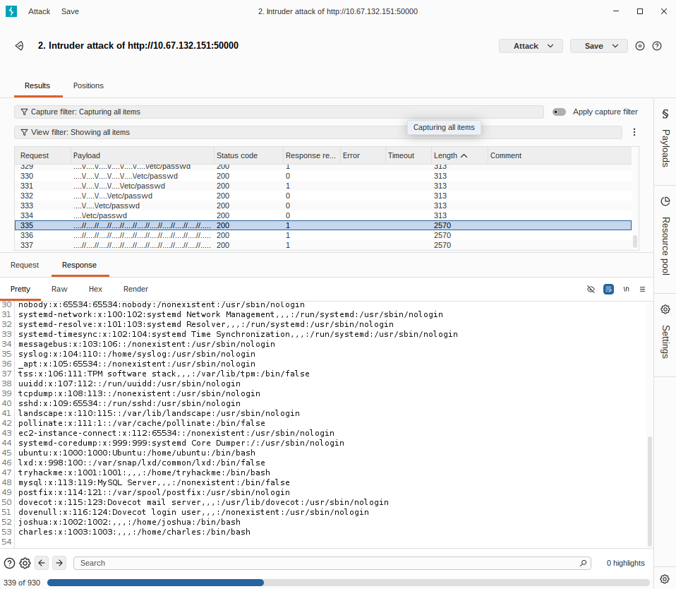
I tried playing with the payload by modifying the directory I want to access using Burp’s Repeater. I tried accessing /etc/shadow in hopes of finding hashed passwords of the users Joshua and Charles, but nothing showed up. Next, I tried accessing log files. Knowing that we discovered services like SMTP, IMAP, and POP3 using nmap, I thought that mail.log could possibly hold useful information. For clearance, mail.log is a log file used by a mail server to record activity related to sending and receiving email. So, I accessed /var/log/mail.log. There, I was able to see mail activities from users.
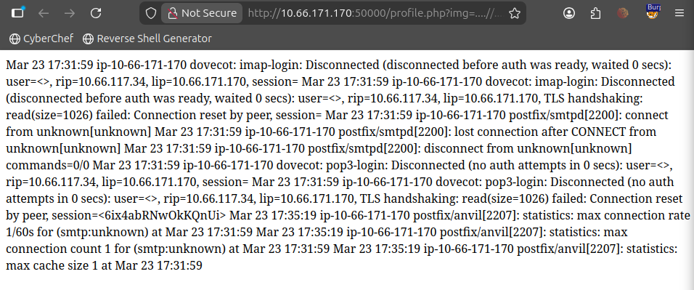
While this might not be showing something meaningful now, it can be a place to retrieve the 2nd flag via log poisoning. Log poisoning is an attack where the attacker inserts malicious code into logs, possibly leading to data leakage…
Since these logs show mail activity, we will need to send an email containing a code that will be logged into the server, allowing us to execute any system command to access /var/www/html.
The following is a simple PHP code that allows us to execute system commands: <?php system($_GET['cmd']); ?>
To send the email, we will use SMTP via Telnet on port 25 (telnet <machine IP> 25).
Before we send the code, we will send a test email to see whether logging works or not, because in real-life scenarios, avoiding risky actions as much as possible is for the best and safety of web applications.
So, I followed up by sending an email to Joshua:
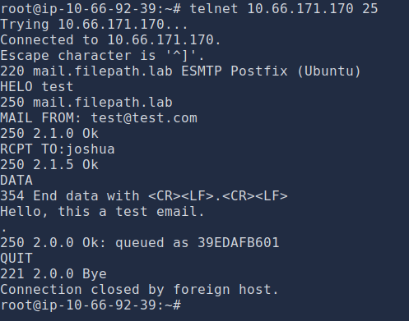
The following Burp Suite result shows successful logging of our email:
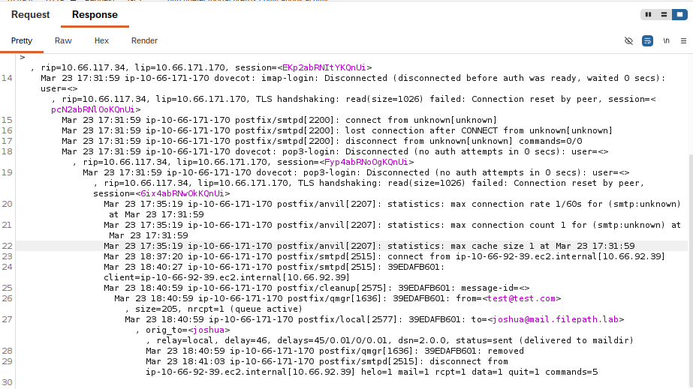
Now, we can send another email, filling in RCPT TO with our PHP command:
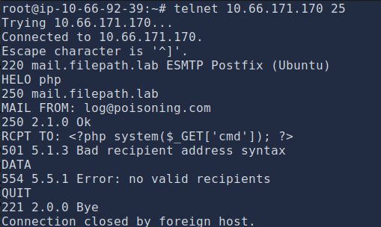
After that, I checked if our empty email was logged.
It seems like the server logged our email. However, we got a warning saying that the syntax contains illegal address in RCPT TO. Nonetheless, this can be enough for our log poisoning.
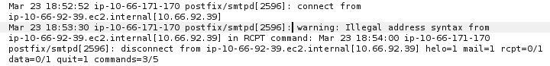
I then passed a whoami command to cmd to verify whether the code was successfully injected or not:
We can see from the image below that the logs show us the response to whoami, i.e. www-data, thus indicating successful log poisoning.
Now, all that is left to do is to retrieve the flag from /var/www/html.
After passing ‘ls’ into cmd, the following are the files and directories inside /var/www/html. The txt file should have our flag.
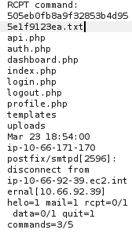
Finally, we can use the ‘cat’ command to read the txt file and retrieve the 2nd flag from the response:
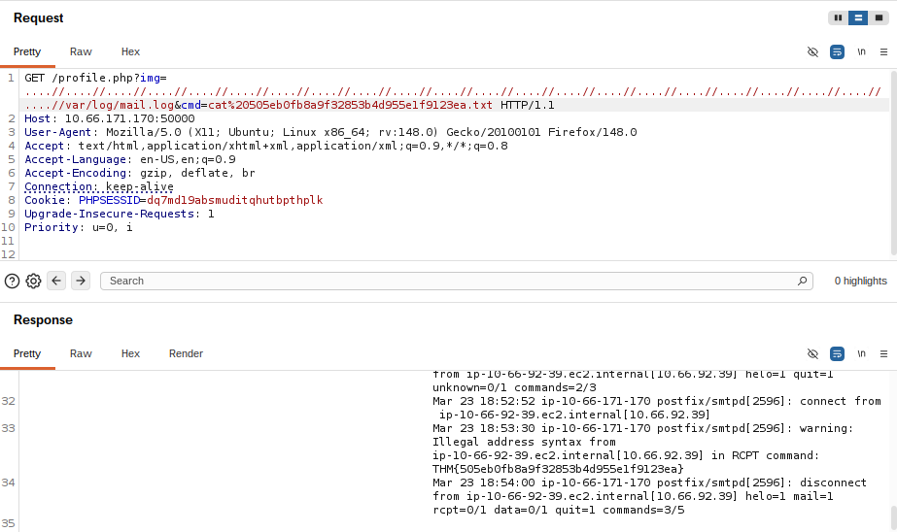
Note the %20 inserted into cmd. To cat a file, the syntax should be cat-space-file. For the command to work, we need to use the URL-encoded version of space, which is %20.
This is the end of the write-up.

